AWS Certified Cloud Practitioner – CLF-C01

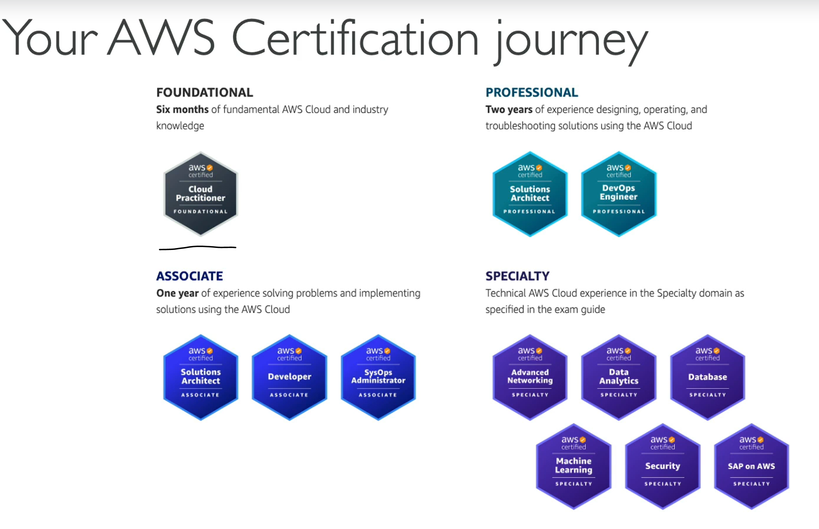AccountName – NavinDhote

AWS Account ID – 906419543401

Canonical User Id - 7bc8aac905ab86b72dbf9ad24891ae3054b35d683be2a9bd4f3ef5a6a83727eb

Email Address - [navin.dhote214@gmail.com](mailto:navin.dhote214@gmail.com)

Password – Navin@12345

Server Components

1. Compute -CPU
2. Memory – RAM
3. Storage – Data
4. Database – Stored Data in structured Way
5. Network – Router, Switch and DNS Server

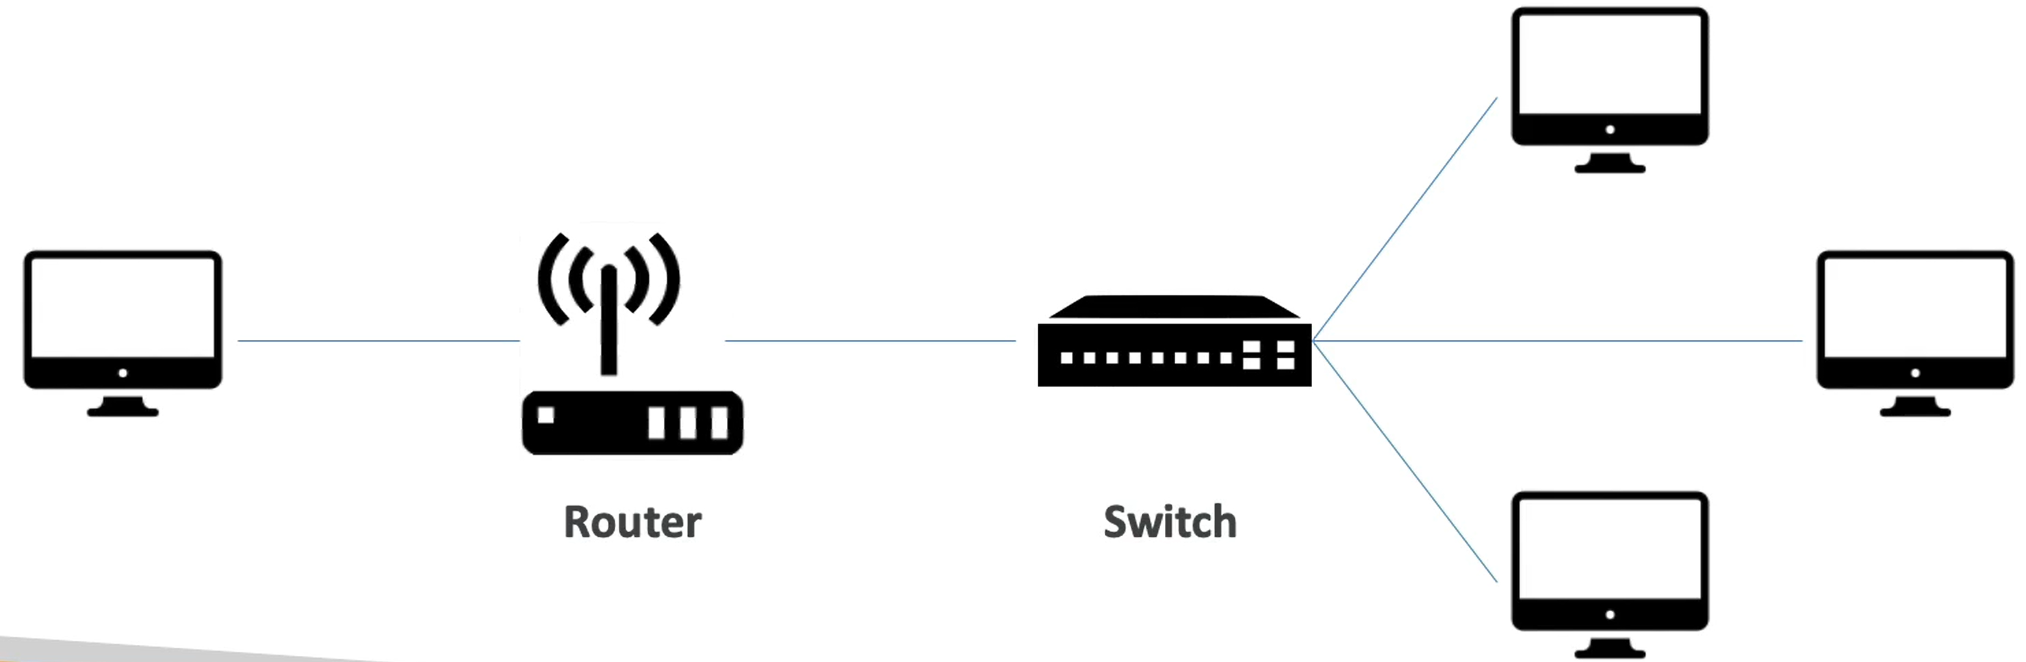

Deployment Models of Cloud

1. Private Cloud – Eg. Rackspace
2. Public Cloud – AWS, Azure, GCP
3. Hybrid Cloud – Private + Public Cloud – Private type use and public type cost

Characteristics of Cloud Computing

1. On-Demand Self Service
2. Broad Network access
3. Multi-tenancy and Resource Pooling
4. Rapid Elasticity and Scalability
5. Measured Service

Advantages of Cloud Computing

1. Trade Capital Expenses (No maintenance Cost)
2. Benefit from massive economies of scale
3. Stop guessing capacity
4. Increased speed and agility
5. No maintenance of data centers
6. Go Global in minutes

Problems resolved by Cloud

1. Flexibility
2. Cost Effectiveness
3. Scalability
4. Elasticity
5. High Availability and Fault Tolerance
6. Agility

Types of Cloud Computing

1. IAAS – Infrastructure as a Service

Provides building blocks such as Storage, Network, On Premises

1. PAAS – Platform as a Service

Focus on Deployment and Management of your applications.

No need to worry about the infrastructure.

1. SAAS - Software as a Service

Completed product run and managed by service provider.

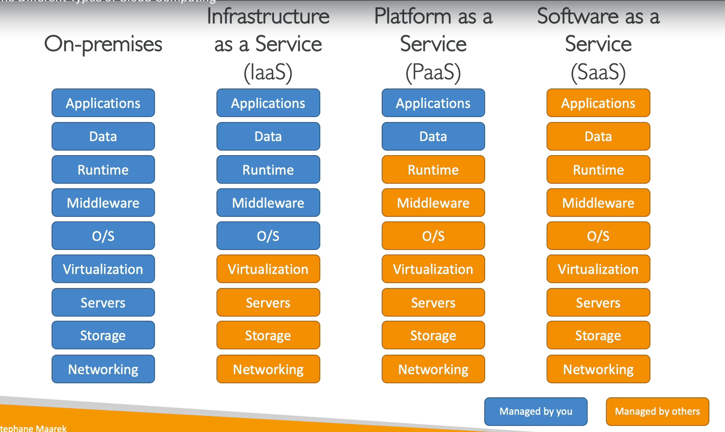

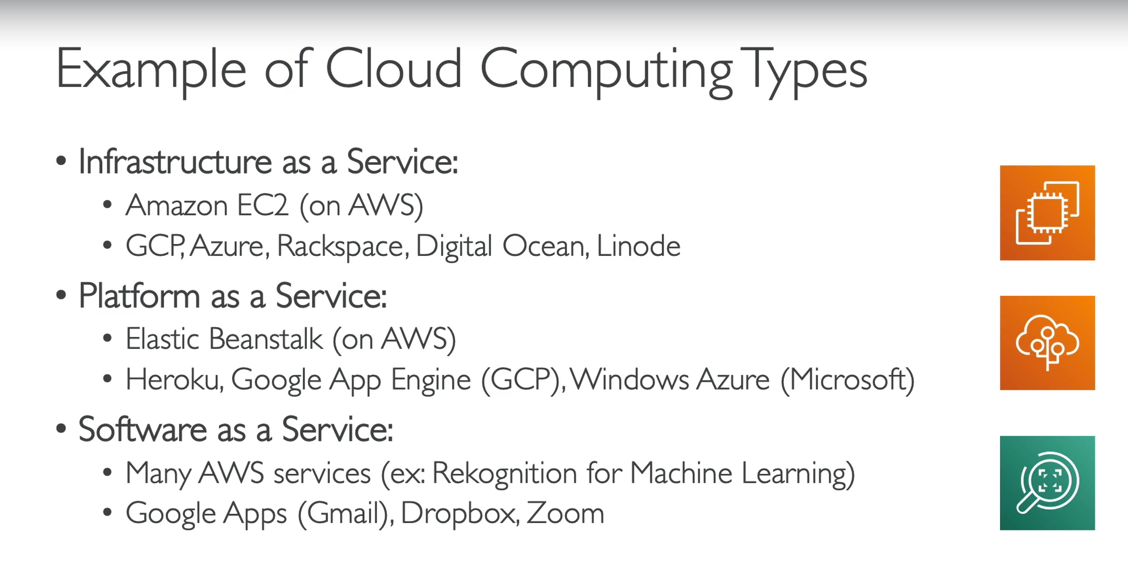

Pricing of the Cloud

Pay As You Go Pricing Model

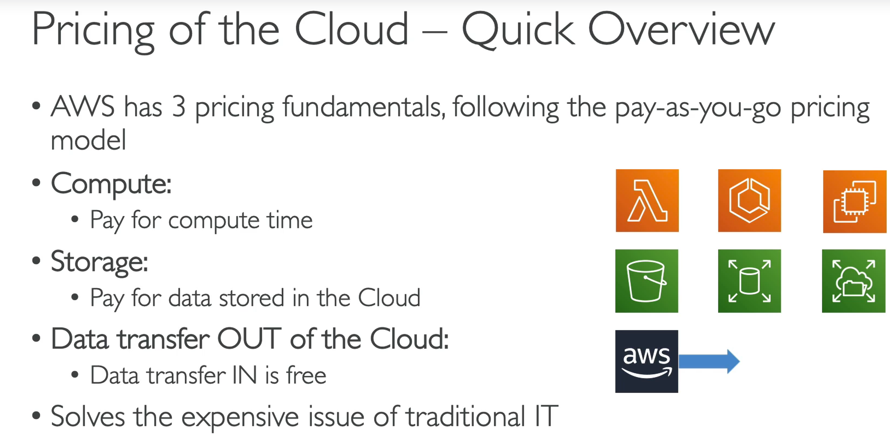

AWS Global infrastructure

1. AWS Regions – A Cluster of Data Centres
2. AWS Availability Zones
3. AWS Data Centers
4. AWS Edge Locations/ Points of Presence

Factors to choose and AWS Region

1. Compliance
2. Proximity to Customers
3. Available Services
4. Pricing

Availability Zones

Each Region is classified or composed of Availability Zones.

Min -2, max- 6, usually – 3

All the Availability Zones in a region are located at different locations so that they are isolated from disasters. They are connected via high networking bandwidth.

Points of Presence

Shared Responsibility Model of AWS

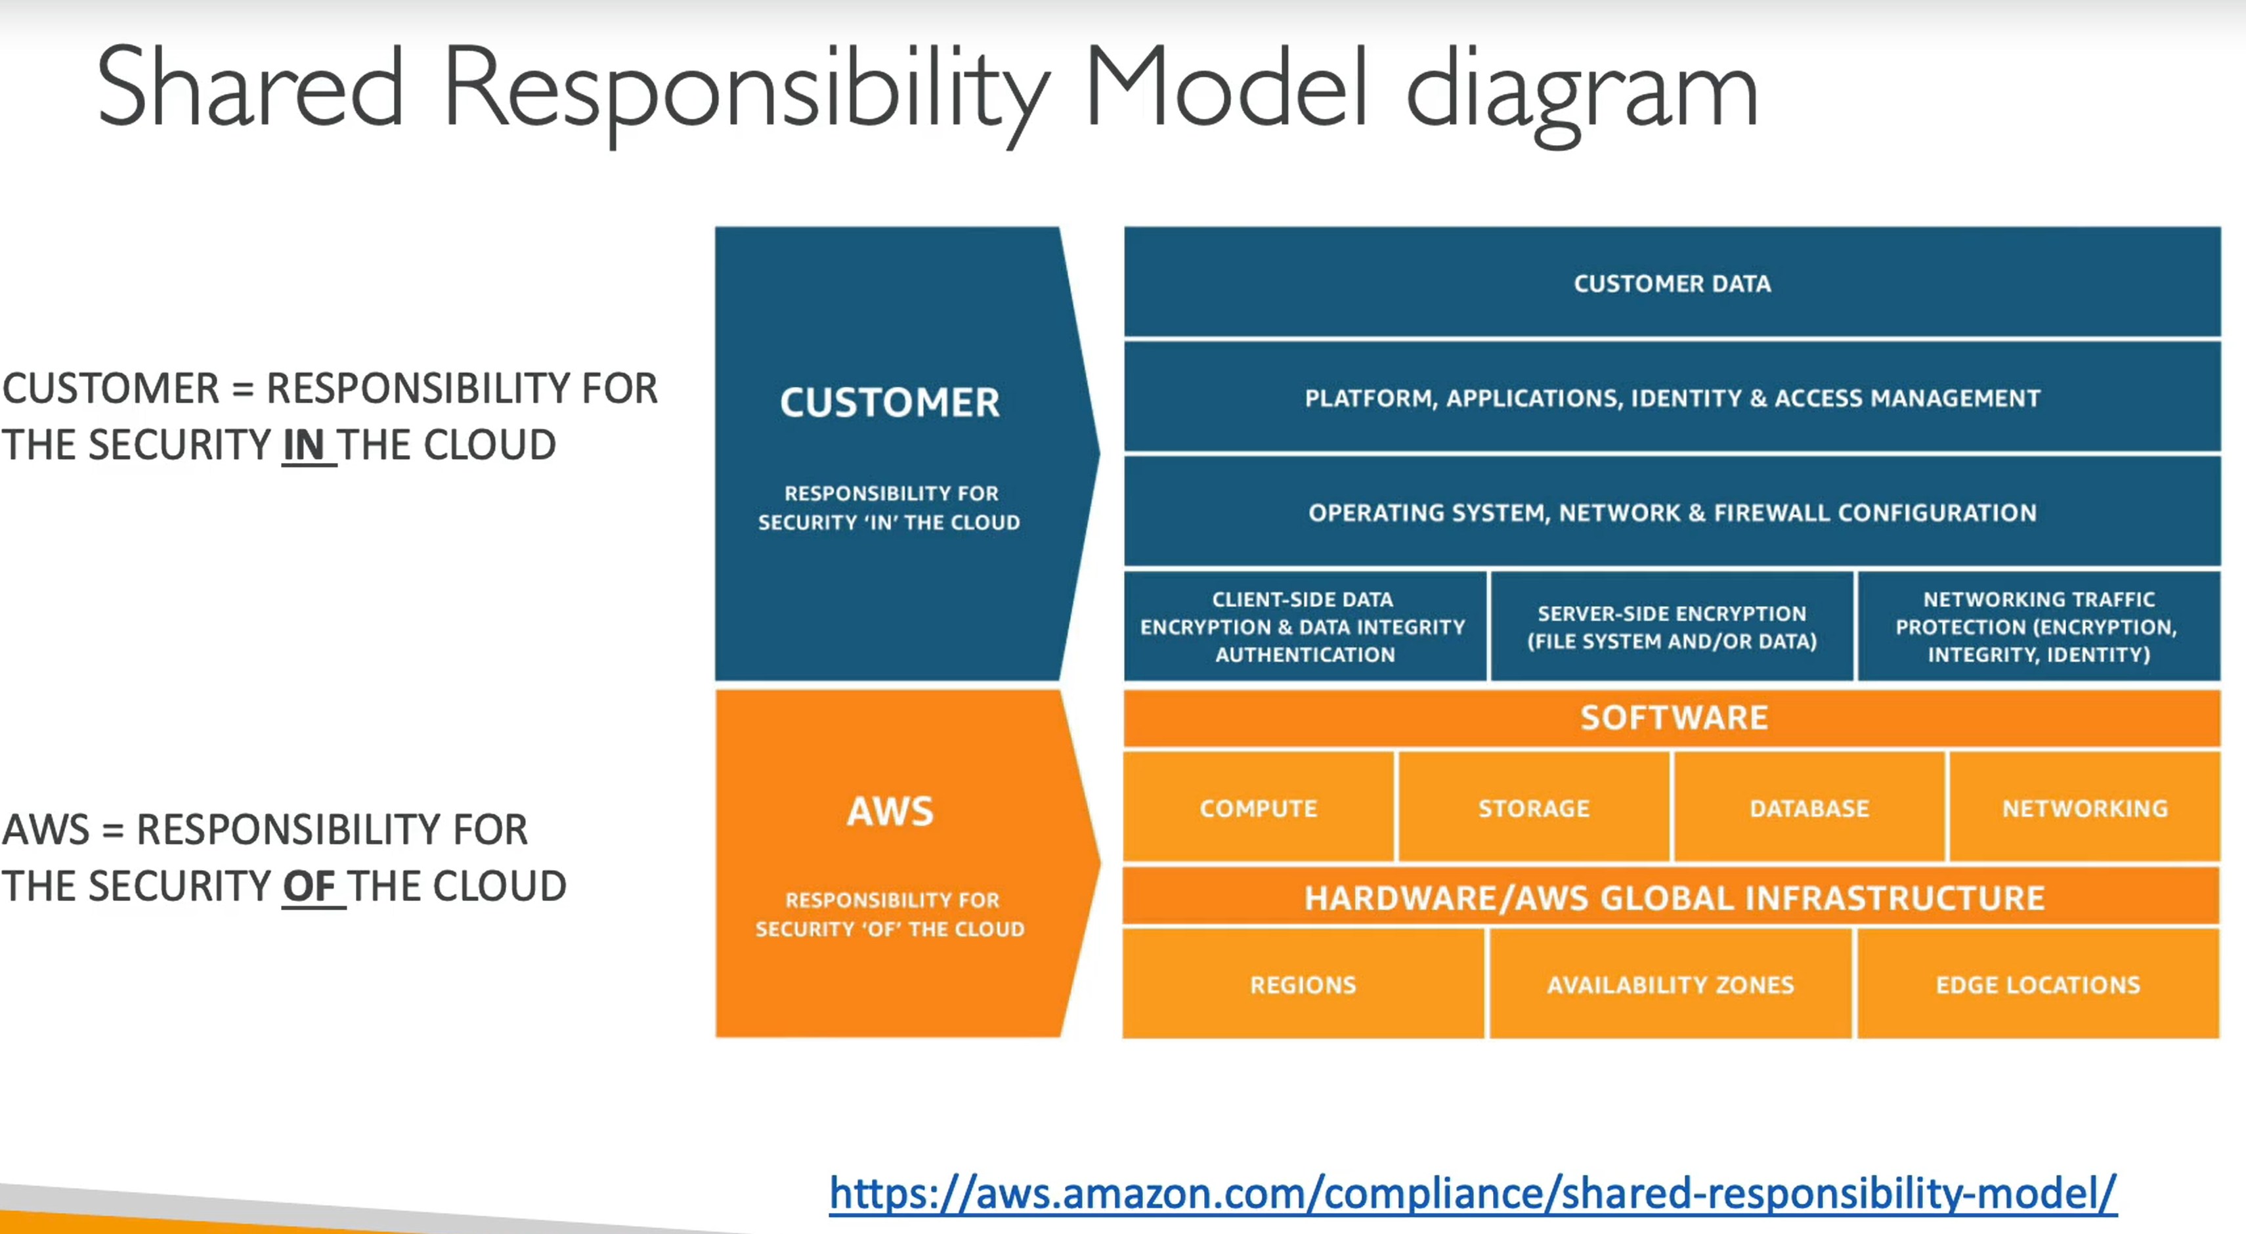

IAM – Identity and Access Management

It’s a Global Service

Root Account should never be used or shared.

IAM – Permissions

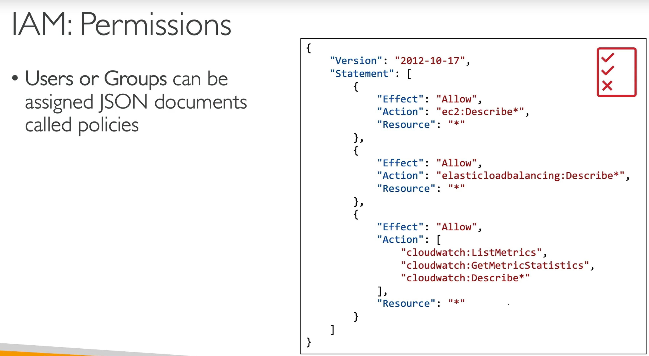

AWS follows a principle called as Least Privilege Principle where you always give the permissions to you user which he needs the least. More or full permissions must not be granted.

Creating Users and Groups

User

arn:aws:iam::906419543401:user/navin

Username - navin

Password - Navinaws@12345

IAM Policies Inheritance

IAM Policies Structure

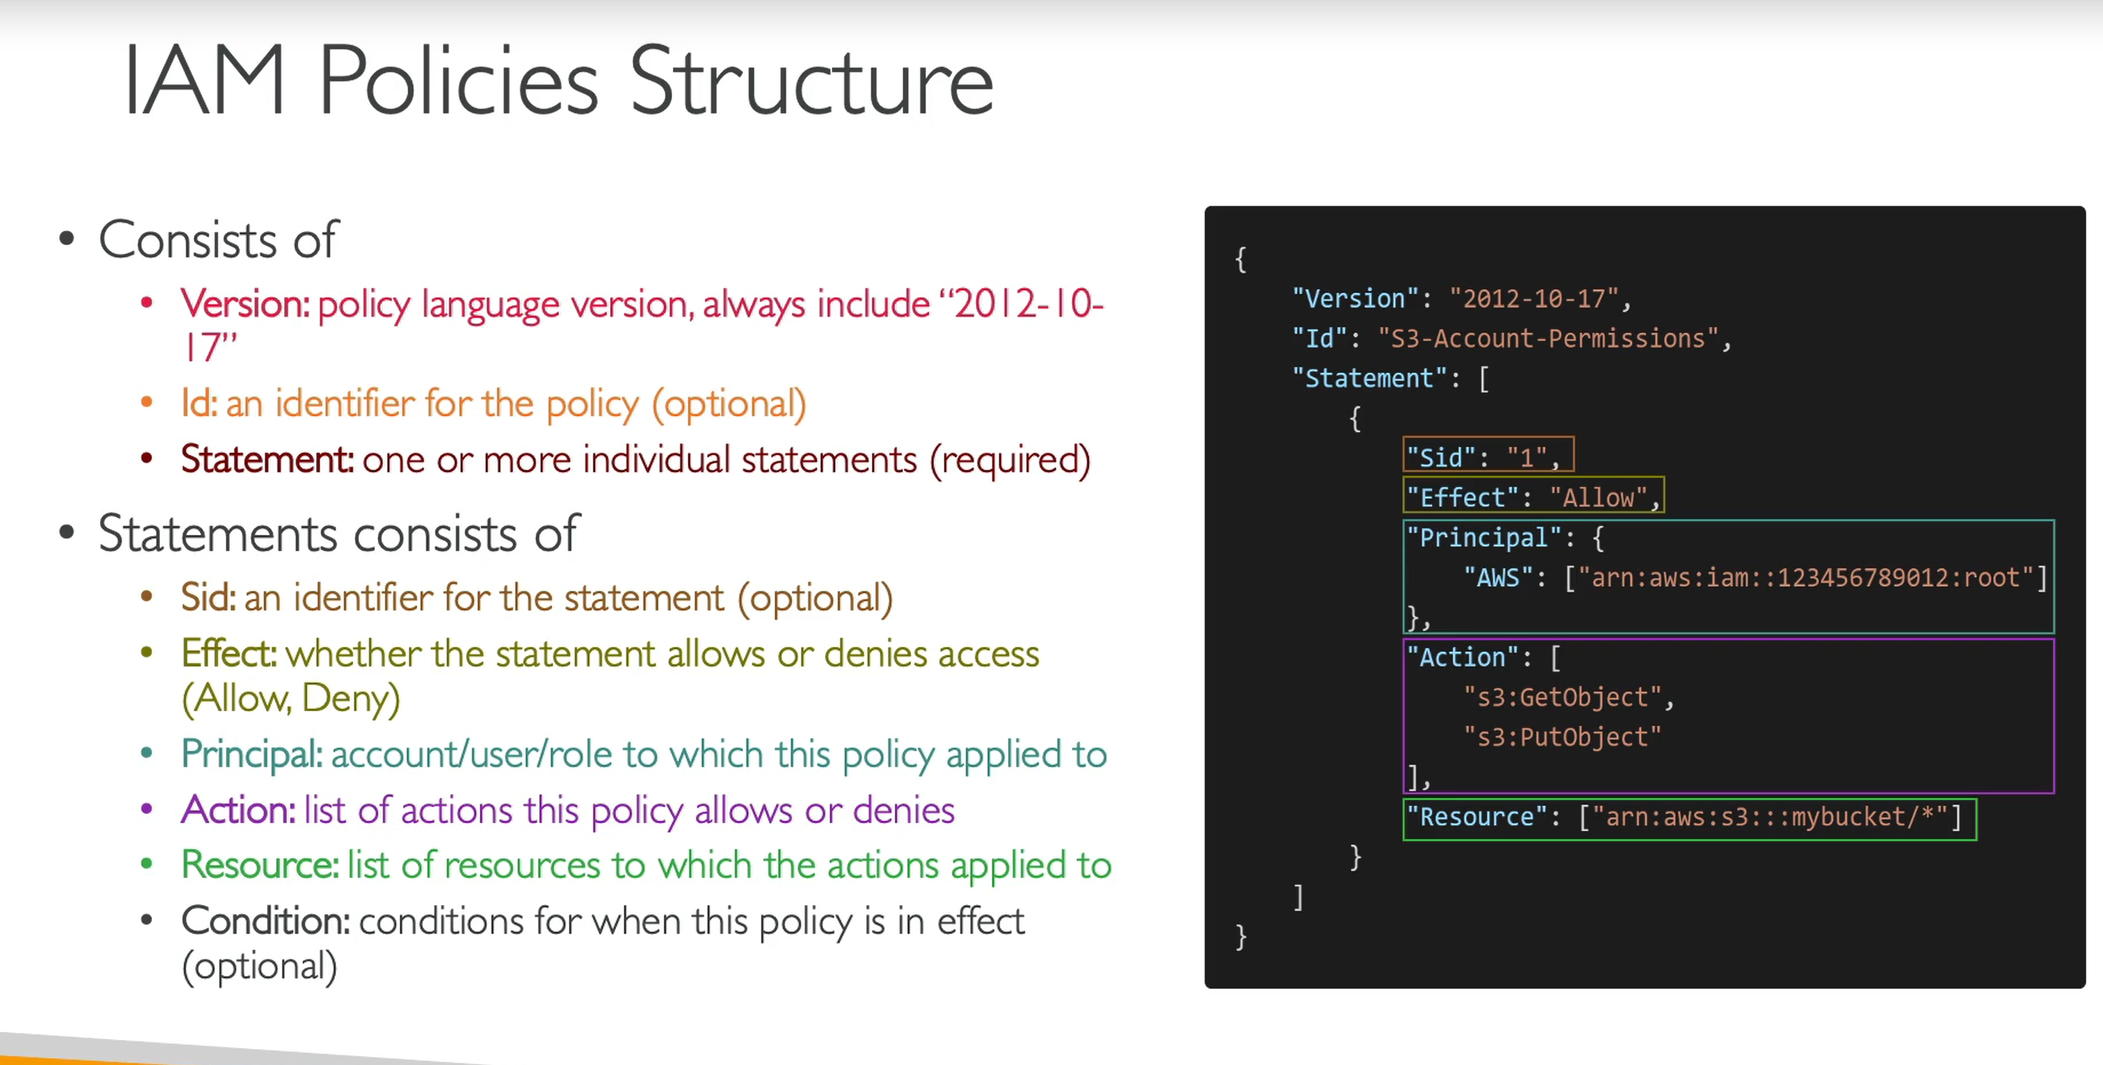

IAM Policy

Can be created either by using Visual Editor or from json.

IAM Password Policy

1. There can be different Password Set Rules
2. MFA Authentication

MFA Device Options

1. Google Authenticator (Phone Only)
2. Authy (Multiple Devices)
3. Yubikey (Physical Device)
4. Hardware Key Fob MFA Device
5. KeyFod given by US Government

Ways to Access AWS

1. AWS Management Console (Password + MFA) – Manage AWS through UI
2. AWS Command Line Interface (CLI – Access Keys) – Manage AWS through Command Line
3. AWS Software Development Kit (SDK – Access Keys) – Manage AWS Programatically

Access Keys generated from AWS console. Do not share your Access Keys

Username – Access Key ID

Password – Secret Access Key

Using AWS Cloud Shell

Open from UI or search Cloud Shell. Its like a CMD from AWS.

Cloud Shell is available only in limited Regions.

You can either use Cloud Shell or AWS CLI Terminal.

IAM Roles for Services

Some AWS services will need to perform actions on your behalf.

To do so, we assign permissions to AWS services with IAM roles.

Common Roles for IAM Roles for Services

1. EC2 Instance Roles
2. Lambda Function Roles
3. Roles for Cloud Formation

IAM Security Tools

1. IAM Credentials Report (Account Level)
2. IAM Access Advisor (User Level)

IAM Guidelines and best practices

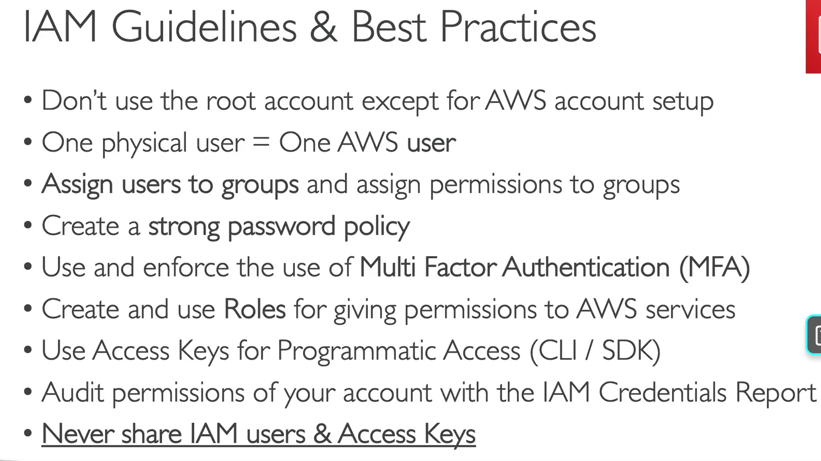

Shared Responsibility Model for IAM

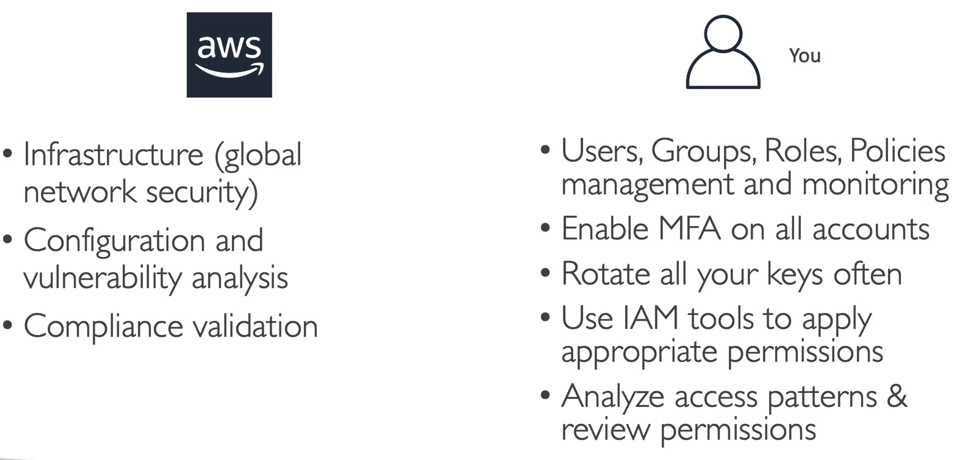

IAM Summary

